# Huawei Nova 7i

# 

## Huawei Nova 7i price in US $

Huawei Nova 7i price in Pakistan is US is $521. Official dealers and warranty providers regulate the retail price of Huawei mobile products in official warranty.

Price of Huawei in USD is $521.

## Huawei Nova 7i - A stunning Smartphone With Outstanding Features

Huawei to come up with Nova 7i to hit the market. It features some amazing specs that can blow your mind. The new handset will feature Kirin 810 SoC. This is a powerful chipset that will ensure outstanding results. Huawei Nova 7i is said to the re-branded version of 6 SE. The SoC of the handset is paired with 8 gigabytes of RAM capacity to ensure the processing speed of the smartphone will be lightning fast. Huawei's Nova 7i is packing 128 gigabytes of built-in storage for keep data for future use. Though the storage capacity of the phone is on the high-end still there is a dedicated slot for making the storage capacity of the Huawei Nova 7i's more sufficient to hold even large amounts of data without any storage problem. It will run Android 10-based EMUI 10 out of the box. The display is one of the main things that is taken under consideration before selecting a smartphone. So the Nova 7i by Huawei will come equipped with 6.4 inches display screen that gives the user full HD plus resolution. The selfie shooter of the handset has moved to the left corner. The selfie shooter of the Huawei 7i will 16 megapixels. Now, moving to the back-end of the device you will see that the smartphone is packed with a quad-camera setup. The main sensor of the Huawei Nova's 7i will be 48 megapixels, 8 megapixels ultra-wide sensor, 2 megapixels macro camera and the depth sensor is going to be 2 megapixels as well. Talking the security of the phone very seriously, the new [Huawei](https://www.whatmobile.com.pk/Huawei_Mobiles_Prices) Nova 7i is packed with a side-mounted fingerprint reader. The battery is 4200 mAh capacity that carries support for 40 W fast charging. [Samsung](https://www.whatmobile.com.pk/Samsung_Mobiles_Prices) has got a competitor in the shape of Nova 7i's in the market.

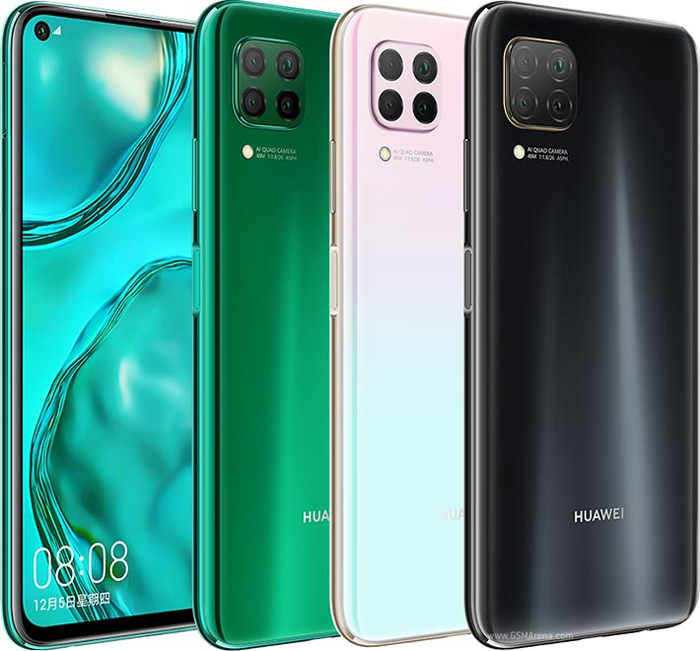

## Huawei Nova 7i detailed specifications

|  |  |  |
| --- | --- | --- |
| **Build** | OS | Android 10 OS |
| UI | EMUI 10 |
| Dimensions | 159.2 x 76.3 x 8.7 mm |
| Weight | 183 g |
| SIM | Dual Sim, Dual Standby (Nano-SIM) |
| Colors | Skyline grey, Midnight Black, Crush Green, Sakura Pink |
| **Frequency** | 2G Band | SIM1: GSM 850 / 900 / 1800 / 1900 SIM2: GSM 850 / 900 / 1800 / 1900 |
| 3G Band | HSDPA 850 / 900 / 2100 |
| 4G Band | LTE band 1(2100), 3(1800), 5(850), 8(900), 38(2600), 39(1900), 40(2300), 41(2500) |
| **Processor** | CPU | Octa-core (2 x 2.27 GHz Cortex-A76 + 6 x 1.88 GHz Cortex-A55) |
| Chipset | HiSilicon Kirin 810 (7 nm) |
| GPU | Mali-G52 MP6 |
| **Display** | Technology | LTPS IPS LCD Capacitive Touchscreen, 16M Colors, Multitouch |
| Size | 6.4 Inches |
| Resolution | 1080 x 2310 Pixels (~398 PPI) |
| Protection | Corning Gorilla Glass |
| **Memory** | Built-in | 128GB Built-in, 8GB RAM, UFS 2.1 |
| Card | Nano Memory Card, (supports up to 256GB) (uses shared SIM slot) |
| **Camera** | Main | Quad Camera: 48 MP, f/1.8, 26mm (wide), 1/2.0", PDAF + 8 MP, f/2.4, (ultrawide) + 2 MP, f/2.4, 27mm (wide), dedicated macro camera + 2 MP, f/2.4, 1/5.0", depth sensor, LED Flash |
| Features | Geo-tagging, touch focus, face detection, HDR, panorama, Video (2160p@30fps, 1080p@30fps) |
| Front | 16 MP, f/2.0, (wide), 1/3.1", HDR, Video (1080p@30fps) |
| **Connectivity** | WLAN | Wi-Fi 802.11 a/b/g/n/ac, dual-band, Wi-Fi Direct, hotspot |
| Bluetooth | v5.1 with A2DP, LE |
| GPS | Yes + A-GPS support, & GLONASS, BDS, GALILEO, QZSS |
| USB | 2.0, Type-C 1.0 reversible connector, USB On-The-Go |
| NFC | No |
| Data | GPRS, Edge, 3G (HSPA 42.2/5.76 Mbps), 4G (LTE-A (2CA) Cat13 400/75 Mbps) |
| **Features** | Sensors | Accelerometer, Compass, Fingerprint (side mounted), G Sensor, Proximity |
| Audio | 3.5mm Audio Jack, MP4/H.264 player, MP3/eAAC+/WAV/Flac player, Speaker Phone |
| Browser | HTML5 |
| Messaging | SMS(threaded view), MMS, Email, Push Mail, IM |
| Games | Built-in + Downloadable |
| Torch | Yes |
| Extra | No Google Play Services, Glass front + plastic back, plastic frame, Active noise cancellation with dedicated mic, Photo/video editor, Document editor |
| **Battery** | Capacity | (Li-Po Non removable), 4200 mAh |
|  | - Fast battery charging 40W (70% in 30min) (advertised) |

|  |  |
| --- | --- |
| **Price** | Price in Rs: 41,999     Price in USD: $209 |
| **Ratings** | Average Rating is 4.4 stars - based on 772 user reviews. |

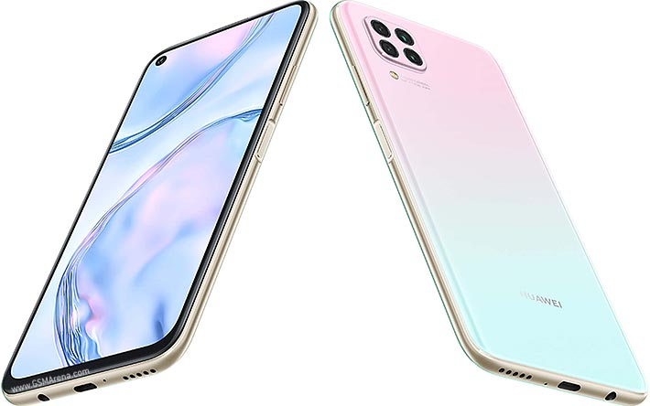

Disclaimer. Huawei Nova 7i price in Pakistan is updated daily from the price list provided by local shops and dealers but we can not guarantee that the information / price / Nova 7i Prices on this page is 100% correct (Human error is possible), always visit your local shop for exact cell phone cost & rate. Huawei Nova 7i price Pakistan.